Origin, Process and Results of the Programme

Title of program-project: | Using of Innovative ICT to Improve Quality of Education in Small Schools in Rural Area
Name of implementing organization: |  | Central China Normal University

Contents
Chapter 1 Background of implementing organization 1
Chapter 2 Background and Origin of Project 1
Chapter 3 Major Problems Solved by the Project 2
Chapter 4 Implementation and Methods of the Project 3
4.1 Investigation (From March, 2013 to December, 2013) 4
4.1.1 Large-scale Field Research of SSRA in Hubei Province 4
4.1.2 In-depth Investigation of SSRA in Xian'an, Chongyang and Enshi 4
4.2 Experiment and Practice (From 2014 to 2015) 5
4.2.1 In-depth Reform of Classroom Teaching Experiment and Practice 7
4.2.2 Innovative Exploration of Teaching Management System and Mechanism 9
4.3 Quality Improvement（From 2015 to 2016） 11
4.3.1 Establishment of Rules and Regulations 11
4.3.2 In-depth Integration of Technology and Teaching 11
4.3.3 Digital Training for Teachers 12
4.3.4 Development Observation of Teachers and Students 13
4.4 Application and Extension（From 2016 to Date） 13
4.4.1 Application and Extension in "Three States (Cities) and Two Counties" 14
4.4.2 Specific Project for Quality Improvement of Network Schools of SSRA in Hubei Province 15
Chapter 5 Implementation Effects and Achievement of the Project 16
5.1 Main Achievements 16
5.1.1 Formed an Overall Solution for Promoting the Quality of SSRA through Informatization 16
5.1.2 Formed a Demonstration of Promoting the Quality of Rural Teaching Centers through Informatization in Promotion 18
5.1.3 Made a Series of Policy Suggestions to the National and Provincial Governments and Relevant Education Authorities 19
5.2 Effects and Reflections 19
5.2.1 Application Effect 20
5.2.2 Social Reaction 20
5.2.3 Practical Reflection 21

Chapter 1 Background of implementing organization
The project is led by Central China Normal University(CCNU), one of the top national normal universities directly under the Ministry of Education of China It is an important base for our country to train teachers and other senior professionals in K-12 education. CCNU continuously explores educational informatization construction and innovate of education mode, which has made positive progress in promoting the integration of ICT and education as well as in reconstruction of educational ecology. CCNU attaches great importance to the social service function of the university and takes an active part in poverty alleviation. It is also very concerned about the education fairness and has been making great efforts to let every child enjoy a fair and high-quality education.
In 2013, the project is started with using innovative ICT to improve the quality of education for small school in rural area (SSRA). This project explores that how can we use ICT to promote teaching and learning quality in SSRA. SSRA is the "last mile" to achieve inclusive and equitable quality education in China. As an important organizational form of compulsory education, SSRA have given great convenience of nearby enrollment to vulnerable student group in remote rural areas. With the collaborative efforts of ICT companies, local governments and K-12 schools, the project team of Central China Normal University proposed “Double-track mixed digital school” model, which based on the “Rural Digital School” ICT platform. In the digital school, some teaching communities of urban and rural teahcers have been build, and the classes of urban schools have been transmitted to SSRA through ICT without changing the school entity. Problems of incomplete subjects, insufficient class hours and low-quality teaching, due to shortage of teachers in SSRA, have been solved. This project has been carried out in 8 provinces and 20 counties (districts) across our country, benefiting more than 50,000 SSRA.

Chapter 2 Background and Origin of Project
Transforming our World: the 2030 Agenda for Sustainable Development set the ambitious goal that ensure inclusive and equitable quality education and promote lifelong learning opportunities for all. The agenda focuses on inclusion and equity, which means giving everyone equal opportunities without leaving anyone behind. That requires a greater focus on marginalized or vulnerable groups. All people should have access to inclusive and equitable quality education and lifelong learning opportunities, in spite of gender, age, race, color, ethnic group, language, religion, political stand, nationality or social origin, property or personal background. And the people with disabilities, immigration, aborigines, children and the young, especially those who are disadvantaged or under other conditions need more attention.
SSRA is the "last mile" to achieve inclusive and equitable quality education in China. As an important organizational form of compulsory education, SSRA have created great convenience of nearby enrollment for vulnerable student group in remote rural areas. According to statistics, the number of SSRA in 2014 was 66,900, accounting for 33.2% of the total number of primary schools in China. However, under the division system between urban and rural areas, there is a serious shortage of qualified teachers in SSRA located in remote rural areas.
Supported by Hubei Provincial Department of Education, this project is relying on Co-Innovation Center for Educational Informatization and Balanced Development of Basic Education(CCEIBDBE) of Central China Normal University. With the supported project from Department of Science and Technology in the Ministry of Education-Research of Development Model and Policy about Education Informatization Supporting the Implementation of Balanced Education in Counties, and the key project of the 13th Five-year Plan of National Education Sciences-Promoting Targeted Poverty Alleviation by Education Informatization, this project implemented strategy of "Internet Plus School, Courses, Teachers and Students", which is centered on the problem of "incomplete subjects, insufficient class hours and low-quality teaching " in SSRA. Through the innovative practice of teaching mode, technical environment and teaching mechanism, we aim at exploring effective ways for promoting SSRA’ quality improvement so that every student there can enjoy an inclusive, fair and high-quality education.

Chapter 3 Major Problems Solved by the Project
In the process of urbanization construction in China, not all parents can bring their children up to maturity. Left-behind children still occupy a large proportion in rural areas and SSRA remain an important part of education in these areas. Generally speaking, most of these SSRA are located in remote rural areas with small teaching scale, little fund, old equipment, limited qualified teachers and low teaching quality. In recent years, despite the continuous development of new urbanization, backward areas are still existing, and the development of remote rural areas, especially the education development of SSRA have not been fundamentally solved. Among them, the most basic and critical problem lies in courses of compulsory education, which is “incomplete subjects, insufficient class hours and low-quality teaching”.
(1) Incomplete subjects: SSRA are lack of teachers in English, music, physical education and arts, etc. And they are ineffective at high-quality digital resources supply for subjects. Thus leads the imperfection of compulsory education subjects that ought to be specified by the state.
(2) Insufficient class hours: because of the backward technical environment in SSRA and the limited coverage of high-quality digital resources of subjects, the classroom hours of music, art, science and other subjects cannot meet the state standards.
(3) Low-quality teaching: the outdated knowledge structure, weak application ability of information technology and old teaching mode of teachers in SSRA make it is difficult to change the teaching and learning mode of teachers and students which come out with a low teaching quality.
This project aims to improve the quality and balanced development of rural weak schools (SSRA) by means of "Internet plus". We hope to use information methods and innovate teaching structure and teaching mode to help the weak schools carry out full subjects with good quality and sufficient hours, to help the teachers improve their professionalism and teaching standards, to support rural left-behind children and their parents’ communication, to support the moral education work and campus culture construction, so as to promote the overall improvement of education teaching level.

Chapter 4 Implementation and Methods of the Project
By using information technology, this project is to solve the problems of "incomplete subjects, insufficient class hours and low-quality teaching" and get through the "last mile" to realize the high-quality balanced development of China's compulsory education. The innovative exploration for the project is mainly through the following stages.

4.1 Investigation (From March, 2013 to December, 2013)

4.1.1 Large-scale Field Research of SSRA in Hubei Province
From March to June, 2013, our project team went for field research and took an in-depth investigation in Hubei Province, e.g., Xian’an District of Xianning City, Chongyang County, Tongshan County, Enshi City in Enshi Prefecture, Laifeng County, Xianfeng County, Suizhou City (Prefecture-level), Guangshui City (Prefecture-level), Macheng City (Prefecture-level), Jianli County. We did comprehensive researches at Hubei SSRA by interview, observation, in-depth interview and other methods.
The research results show that it is extremely short of excellent teachers in Hubei SSRA and it is hard to realize “complete subjects, sufficient class hours and high-quality teaching”; There are still many students in SSRA and the proportion of left-behind children is high; Infrastructure and conditions are not balanced, and the management level and efficiency of facilities are low.
Based on research results, we submitted investigation report about the Current Teaching Status of Hubei SSRA to Hubei Ministry of Education, and suggested carrying out “Ridge Digital Schools” construction to explore the methods in solving the problems of "incomplete subjects, insufficient class hours and low-quality teaching" by using information technology, and to track out the effective mode and path under the condition of informatization in improving SSRA’ quality.

4.1.2 In-depth Investigation of SSRA in Xian'an, Chongyang and Enshi
From June to December, 2013, with the assistance of Fundamental Education Department, Hubei Ministry of Education, we chose Xian’an District, Chongyang County and Enshi City (Prefecture-level) as pilot experimental area for using informatization in improving SSRA’ quality. Through several field surveys, we had further in-depth investigation and more detailed problem analysis on reform of SSRA, education informatization construction and development, as well as the high-quality balanced development of China’s compulsory education in these three areas. Also, we helped them find out the crux of their problems respectively and reached preliminary cooperation intention with the people's governments of these three counties (cities, districts) above.

4.2 Experiment and Practice (From 2014 to 2015)
Aim at the problem of "incomplete subjects, insufficient class hours and low-quality teaching" in SSRA, we designed a relatively complete solution, carried out experiments and practical explorations from part to the whole in pilot areas, and push forward the balanced development of compulsory education under education informatization. It was mainly divided into three stages as shown in figure 1.
The first picture of figure 1 showed the experiment and practice of constructing a teaching community formed by one center school driving M (M is 1-2) SSRA around it from February to August, 2014. The second picture showed the experiment and practice of constructing school coalitions formed by N (1+M) teaching communities in pilot areas from September, 2014 to January, 2015, the value of N was three then. The third picture showed the construction practice of virtual-real double-track digital schools in counties from February to August, 2015, and we connected all SSRA in the area with the urban central schools.
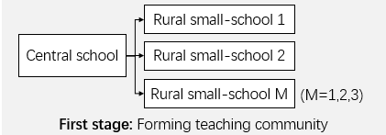
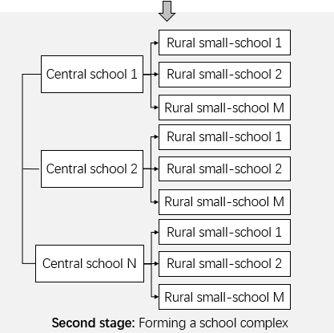
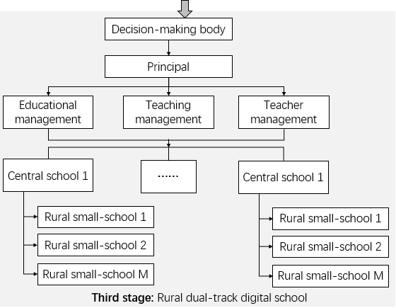
Figure 1 Three Stages of Experiment and Practice from Part to Whole
The experiment and practice exploration of "Internet plus schools", "Internet plus classrooms", "Internet plus teachers" and "Internet plus students" strategy is specifically into two aspects: In-depth reform of classroom teaching experiment and practice, and innovative exploration of teaching management system and mechanism.

4.2.1 In-depth Reform of Classroom Teaching Experiment and Practice (the First Half of 2014)
In view of the poor teaching quality of Chinese, mathematics and other major courses in SSRA, as well as the difficulties in offering music, arts and other subjects, we did pilot experiments in Xian’an District and Chongyang County, Hubei Province. Four innovative teaching modes of informatization are proposed according to different problems.
- Synchronous Interactive Blended Class
Since the shortage of excellent teachers in SSRA, and the problem of "incomplete subjects, insufficient class hours and low-quality teaching" in weak subjects such as English, fine arts and music, etc., we adopted the strategy of "Internet plus" to realize the interconnection between urban and rural areas, and to build a synchronous interactive blended classroom in Xian 'an District (As shown in figure
Synchronous interactive blended class refers to the realization of interconnection between urban and rural areas by the use of network, which implemented the transmission of the whole process of synchronous classroom between “local classes” of center schools in town and the "live classes" assisted by SSRA. Besides, it made an access to communication between teachers and students in local classrooms and other places. This is a teaching form of realizing high-quality education resources sharing by using information technology, so as to help solve the problem of inadequate teaching staffs, which can meet the specified requirements by the state with a full range of teaching subjects and sufficient class hours.
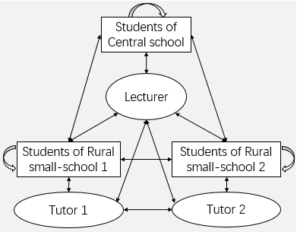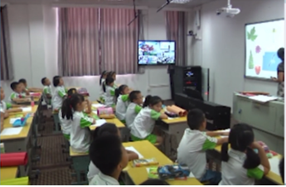
Figure 2 Synchronous Interactive Blended Class
(2)Synchronous Interactive Specified Courier Class
Considering the differences between rural teaching school students and center school students for a better teaching design and teaching implementation, we built the synchronous interactive specified courier class in Congyang County (As shown in figure 3), i.e. the excellent teachers in town schools merely proceed the synchronous teaching for students from different SSRA and realize the real-time interaction between the leading teachers and those students while not assigning students in local classrooms, in this way the leading teachers can take better care of SSRA’ students' cognitive characteristics, knowledge base and learning needs so as to improve their learning effect.
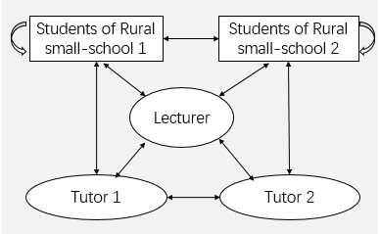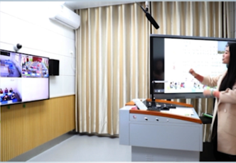
Figure 3 Synchronous Interactive Specified Courier Class
(3) Multimedia Classroom Based on Systematic Digital Resources
On account of teachers’ actual needs for local classroom teaching implementation in SSRA, a multimedia classroom teaching mode with the support of systematic digital resources was formed under full coverage by high-quality digital resources (As shown in figure 4). Its main purpose is to complete the information-based teaching facilities in SSRA, introduce various kinds of high-quality education resources to provide important supplements for teachers' teaching in class, and to help them enrich the teaching contents and forms which can meet the needs better in carrying out local classroom teaching such as Chinese and mathematics.
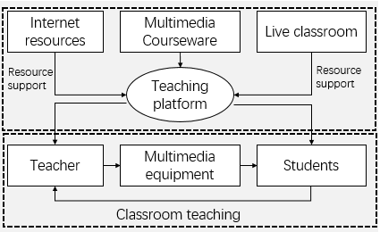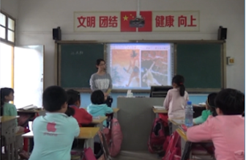
Figure 4 Multimedia Classroom Based on Systematic Digital Resources
(4) Organized MOOCs Pattern
Organized MOOCs Pattern exploration was conducted for the shortage of professional teachers in local courses such as life safety education and mental health education in Hubei Province (As shown in figure 5), i.e., to build education cloud platform for local courses in Hubei Province, and provide diversified learning environment and high-quality digital learning resources with whole learning sections and multiple types, so that students in SSRA can learn in an organized and constrained environment, and these schools can offer and satisfy Hubei local courses such as life safety education and mental health education.
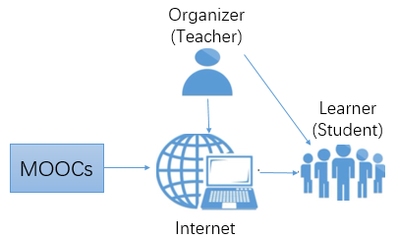
Figure 5 Organized MOOCs Pattern

4.2.2 Innovative Exploration of Teaching Management System and Mechanism (the Second Half of 2014)
The structural reform of classroom teaching focusing on the innovation practice of teaching mode needs the guarantee of corresponding management system and mechanism. Develop the exploration of new management system and mechanism in the innovative experiment and practice of the above information-based teaching mode, and link multiple teaching communities together to form a school with independent construction, layer-management and virtual reality.
Since the second half of 2014, systematism and systematic experimental practice have been carried out in Xian’an District of Hubei Province, and the dual-track rural digital schools with urban-rural integration have been constructed in the mode of county-centered and town-nodded, and taking village primary schools and SSRA as the symptom.
We did a lot of work for dual-track digital schools, e.g. formulation and improvement constitution of dual-track digital schools, the construction and application system of digital teaching resources, regulations on teaching activities of SSRA and Small-Medium Schools, and regulations on "online and offline" teaching system of digital school teachers, etc., providing institutional guarantee for the reform of teaching structure and innovation of teaching mode.
In the practical exploration of the construction and operation of dual-track digital schools, a new management system and mechanism has gradually formed:
(1) The collaborative innovation mechanism, which established a new UGBS collaborative mechanism with "the government as the leading role and normal universities and colleges, enterprises and operators as the joint participants". This mechanism realized the extensive digital resources sharing in SSRA and the efficient flow of high-quality teaching information.
(2) The application-oriented mechanism, which is based on the demand for balanced development of regional basis education and it closely focuses on the design and development of all kinds of information technology and teaching mode applications for the services required by the SSRA of “offering classes with complete subjects, sufficient hours and high standard”.
(3) The technical support mechanism, which integrates the existing market forces to do a good job in hardware maintenance, software use and network communication technology upgrading, so as to guarantee the normal, sustained and stable operation of the "Ridge Digital School" platform and the barrier-free application of various new information teaching modes.

4.3 Quality Improvement（From 2015 to 2016）
At this stage, how to improve the education quality in the SSRA is the core task after solving the problem of "incomplete subjects and insufficient class hours”. Since the first half of 2015, we have been working closely with experimental districts such as Xian 'an, Chongyang and Enshi to improve the teaching quality of SSRA through information-based means.

4.3.1 Establishment of Rules and Regulations (from January to March, 2015)
(1) Improve the management mechanism featuring independent institution, layer management and virtual-reality combination, establish an organizational management system such as school affairs management and teaching management for dual-track blended digital schools, and build a teaching cooperative operation mechanism between center schools and SSRA to ensure the regular teaching work.
(2) Enact the methods for calculating the teaching workload of teachers in blended classrooms and for training, evaluating and rewarding excellent teachers. Establish the system for regular interaction between digital schools and parents, and the regulation of fund raising and application management to improve the institutional environment of digital schools.

4.3.2 In-depth Integration of Technology and Teaching（from March to June , 2015）
(1) Establish teacher information space, and guide primary and secondary school teachers to real-name registration online for personal information space, so as to gradually enrich the space contents in the teaching application, which can promote the network virtual teaching and collaborative lesson preparation based on teachers’ personal information space at SSRA;
(2) With the discipline as the starting point and the discipline teaching demand as the driving force, we actively promoted the construction of teachers' information space and carry out the research and study activities based on "one teacher for one excellent lesson", "one lesson with one excellent teacher" and "heterogeneous forms for the same subject", so as to build customized digital resources oriented to SSRA and gradually realize "excellent lessons and resources";
(3) To build a discipline teaching research team with multiple participation and integration of "offline and online", formulate an information-based teaching research plan, carry out preliminary information-based teaching research, promote the improvement of information technology application ability of teachers in SSRA, and realize the subject teaching informatization;
(4) Actively promote the course teaching and research activities under the information environment, enrich the research contents of the teaching and research team with teachers as the main subject, enrich the strategy and path of the integration of information technology and course teaching, promote the deep integration of information technology and teaching, and improve the quality of course teaching.

4.3.3 Digital Training for Teachers (from April to June, 2015）
(1) Information-based leadership training for principals. It is mainly trained by specialist teams for the principals of all primary and secondary schools in the experimental area, which in order to improve their correct understanding of education informatization, cultivate their planning ability in school informatization construction, and grasp the promotion strategy of informatization construction and application in schools and SSRA.
(2) Backbone teachers training. The training specialist team will explain the main contents of the training and assign the homework to be submitted for the training. Then the backbone teachers will be divided into several groups, and each group will have a graduate assistant to help them complete the training work. Through TPACK knowledge and skills training, the information-based teaching ability of backbone teachers can be further improved.
(3) All-teacher training is by way of school-based training, and the graduate assistants team will be divided into several groups to the schools for a two-day training, which is to develop a new round of "practical exercise, theoretical research" training activities for rural primary and secondary school teachers, especially to those teachers in SSRA, so as to realize the comprehensive promotion of TPACK ability for teachers in center schools and SSRA, and the leap in informationization teaching innovation.

4.3.4 Development Observation of Teachers and Students (from June to December, 2015）
(1) The project preliminary studied and formulated the assessment scales for teachers’ informational teaching ability development at SSRA and the students' growth tracking, and initially established the dimensions and sub-items of information teaching evaluation, which formed a relatively complete observation system for the development of teachers and students at SSRA.
(2) Track and observe SSRA teachers’ development and students’ growth, and study its growth pattern, thus to improve ideas on optimized information-based teaching process. At the same time, the project conducted an in-depth research on the informationized classroom teaching evaluation and established the evaluation method and system of informationalized teaching, as well as preliminary implementation.

4.4 Application and Extension（From 2016 to Date）
From January 2016 to date, we have been promoting the effective mode of using information technology for quality improvement of SSRA in representative regions nationwide, including Changbai Mountain Area, Mufu Mountain Area and Dabie Mountain Area, Wuling Mountain Area and Wumeng Mountain Area, etc. Meanwhile, being entrusted by Hubei Ministry of Education, we launched the special action plan for improving the quality of online schools in SSRA to steadily improve the quality of SSRA. The specific application extension areas are as shown in figure 6.
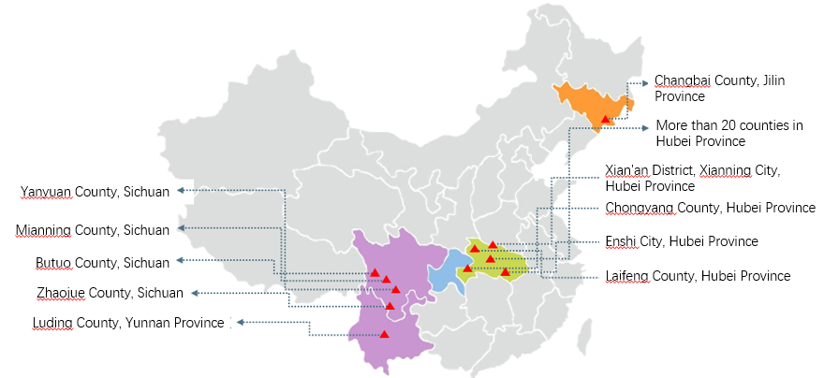
Figure 6 Chart of Specific Application Extension Areas with
“Practice of Informatization Helps SSRA Improve Quality”

4.4.1 Application and Extension in "Three States (Cities) and Two Counties"
We have signed strategic cooperation agreements with Zhaojue County and Butuo County of Liangshan, Sichuan Province, Changbai Korean Ethnic Autonomous County, Jilin Province and Mouding County, Yunnan Province, etc. In view of the geographical location, economic and social development status and education development status of these regions, we promoted the effective mode of using information technology for quality improvement of SSRA. It mainly includes dual-track digital school mode, urban-rural mutual aid "double division" mode, organized MOOCs mode and full coverage mode by relevance digital educational resources. The common characteristics of these four patterns is that using information technology to make SSRA also enjoy the high-quality resources, including teacher resources and digital education resource, under the condition of maintaining the local teacher allocation, and solve the structural shortage of rural school teachers and the problem of "incomplete subjects, insufficient class hours and low-quality teaching", so as to realize the overall improvement in education quality of SSRA.

4.4.2 Specific Project for Quality Improvement of Network Schools of SSRA in Hubei Province
The difficulty in realizing the high-quality balanced development of compulsory education in Hubei Province lies in the significant teaching quality improvement for more than 200 SSRA of 20 more counties within two to three years. For this purpose, specific project for quality improvement of network schools of SSRA is carried out in Hubei Province. In view of this plan, four research teams were established, including the construction and planning of rural digital schools, teaching of rural digital schools, technical support of rural digital schools, and evaluation of rural digital schools. The plan adopted chief expert responsibility system. The team members are the responsible persons of relevant departments (division) from Hubei Ministry (Bureau) of Education, the relevant staffs from colleges and universities, enterprises, teaching academy, and primary and secondary schools. All the research teams collaboratively tracked the quality improvement of SSRA. They went about their respective terms of references while coordinating with each other and overcome difficulties, thus obviously enhanced the teaching quality of SSRA in Hubei Province.

Chapter 5 Implementation Effects and Achievement of the Project

5.1 Main Achievements
After long-term practice and exploration, this project has formed an overall solution for promoting the quality of SSRA through informatization and formed its corresponding demonstration, as well as put forward a series of policy suggestions to the national and provincial governments and relevant education competent departments.

5.1.1 Formed an Overall Solution for Promoting the Quality of SSRA through Informatization
This overall solution drives the in-depth reform of classroom teaching structure and organization management, which makes a feature of "Internet plus" with teaching mode innovation as the main subject, and taking the innovation of teaching environmental resources and teacher training mode as two wings, making data-driven student development assessment system mode and UGBS four-party coordinated mechanism innovation as the guarantee.
5.1.1.1 New Teaching Model of “Internet plus”
Synchronous interactive blended class based on dual-track digital school solved the problem of inadequate teaching staffs and "offering classes without complete subjects”, and effectively promoted the long-distance interaction between teachers and students, which improve the teaching quality. Synchronous interactive specified courier class allowed excellent teacher resources to be in the classroom of SSRA crossed time and space by means of internet. Organized MOOCs mode, by virtue of the internet, made remote SSRA be covered with high-quality open digital teaching resources worldwide, which solved the problem of insufficient effective supply of high-quality digital resources. Multimedia classes based on all media resources achieve full coverage of high-quality education resources by means of traditional multimedia technology environment. Multimedia classroom based on omnimedia resources with the help of traditional multimedia technology environment realized the full coverage of high-quality education resources.
5.1.1.2 Teaching organization and management structure of “Internet Plus”
Based on internet, the constructed dual-track digital schools with urban-rural integration is county-centered, town-noded, entities-operating, and taking village primary schools and SSRA as the symptom with layer management and virtual-reality combination. And on the basis of innovative application of the course teaching mode, the dual-track digital schools realized the deep reform of the classroom teaching structure and the teaching organization and management structure in SSRA. The coverage of high-quality education resources is expanded by means of co-construction and sharing. This is not merely enable SSRA to acquire urgently needed high-quality and scarce curriculum resources, but more importantly motivate the internal flow and sharing of excellent teacher resources in urban and rural schools and SSRA.
5.1.1.3 Teaching Resources and Environment of “Internet Plus”
“Rural Digital School” and “Primary and Middle School Mental Health Education Cloud Platform”, the supporting platforms of dual-track digital schools, gathers excellent teacher resources and high-quality digital teaching resources. These platforms independently developed the high-quality digital resources for six main courses, which can effectively support the new information teaching modes, such as synchronous hybrid class, synchronous specified courier class and multimedia class, etc. They can make city excellent teachers teach all subjects to the students in SSRA, and help these SSRA meet the specified requirements by the state with a full range of teaching subjects and high quality.
5.1.1.4 Four-aspect Coordinated Digital Training System for Teachers
Digital training system for teachers, which based on framework of “integrated technological pedagogical and content knowledge” (TPACK), is through four combination, namely, the combination of technology application, teaching method and subject content, the combination of offline training and online counseling, the combination of training and research, the combination of the training process and the teaching work. This system worked on creating urban and rural community of teachers, for providing a solid guarantee of sustainable development on SSRA’ teachers' information technology application ability and their innovative information-based teaching ability.
5.1.1.5 Data-driven Student Development Assessment System Mode
This assessment system mode set up the tracking observation of students' growth and the multiple evaluation system that took comprehensive quality evaluation as the core and the all-round development as the guidance combining the online and offline practice. Utilizing the means such as Internet and data analysis and combining the development practice of the rural school students with the development of Chinese students’ core literacy as the basic framework, it tracked and evaluated on six basic literacy of SSRA’ students from all-round and all-process perspective, namely, humanities inside, scientific spirit, learning ability, healthy living, taking responsibility, innovation practice.
5.1.1.6 UGBS Four-party Coordinated Mechanism Guarantee
Mechanism for promoting the quality of SSRA through informatization is established by four coordinated parties, which are university (U), government (G), business(B) and primary and secondary school (S). This mechanism takes the normal operation of the "dual-track blended digital school" as the core and includes a series of rules and regulations, e.g. funding mechanism, staff incentive mechanism, technical support mechanism, digital school regulation, blended-classroom teaching management, the students learning activity organization, teaching resources construction and application, online and offline teaching research management, activity management in center schools and SSRA.
(The details of the above achievements is embodied in the thesis, academic works, dissertations and theses and major projects in the supporting materials.)

5.1.2 Formed a Demonstration of Promoting the Quality of Rural Teaching Centers through Informatization in Promotion
Since the first half of 2014, combined with local characteristics, we carried out the teaching practice from point and surface in Xian’an District, Enshi City, Chongyang County, Laifeng County, Guangshui City, Hubei Province, Liangshan Prefecture, Butuo County, Sichuan Province, and Changbai County, Jilin Province, etc., which formed the model demonstration for promoting the quality of SSRA through informatization. For example, Hubei Xian’an experimental area was awarded the “Special Practice Award in National Education Informatization Innovation Application Model Demonstration Area” in 2015 and Hubei Enshi experimental area was widely recommended in education informatization conference. The model of joint-online teaching in Chongyang County has effectively reduced the gap between urban and rural areas which also played a role in function of typical demonstration through out the country.

5.1.3 Made a Series of Policy Suggestions to the National and Provincial Governments and Relevant Education Authorities
Since 2013 to this day, we have made some suggestions to national and provincial governments on improving SSRA’ quality under education informatization and promoting high-quality balanced development of compulsory education.
(1) Ten policy suggestions: Modes and Policy Suggestions on Balanced Development of Basic Education under Support of Education Informatization in County Area(Department of General Reform, Ministry of Education,2017 ); Suggestions on Building Hubei Ridge Digital Schools and Promoting Balanced Development of Basic Education (Hubei Provincial Government, 2014), etc.
(2) Six bills and proposals: Advice of Vigorously Promoting the Deep Integration of Information Technology and Teaching and Deepening the Comprehensive Reform of Education; Developing Good Supporting Policies to Promote Targeted Education Alleviation; Suggestion of Accelerating the Promotion of Education Informatization; Suggestions for Promoting the Balanced Education Development in Weak Remote SSRA; Suggestions on Strengthening the Construction of SSRA; Targeted Poverty Alleviation: Great Potential of Education Informatization.

5.2 Effects and Reflections
At present, the experimental area has covered more than 1,000 SSRA of 20 more counties in eight provinces (cities) and benefited over 50,000 students. According to the follow-up investigation of experimental areas such as Xian 'an, Chongyang, Enshi and Zhaojue, a series of practical explorations have effectively solved the problems of "incomplete subjects, insufficient class hours and low-quality teaching", which effectively promoted the quality of SSRA and has been widely recognized by all sectors of society.

5.2.1 Application Effect
First, the problem of “incomplete subjects and insufficient class hours” have been addressed fundamentally. In the past, English, music, art and other subjects that could not be fully offered in the SSRA in the experimental areas, while now the subject completion rate can reach 100%, and the class hour achieved rate is above 98%.
Second, SSRA’ students’ academic achievement level is significantly enhanced. Students' learning interest, self-efficacy and academic record have all undergone positive changes. The investigation shows that the students' academic record and their comprehensive quality in the experimental area are obviously higher than those in the non-experimental area.
Third, the student churn rate in SSRA has declined dramatically. The survey showed that 90.2% of the teachers and 95.5% of the leaders of the principals in SSRA believed that "the students’ number in the SSRA is significantly increased than before".
Fourth, teachers' information technology application ability has been significantly enhanced. In the SSRA in the experimental areas, 40% of the teachers reached the excellent level, and 50% reached the good level on information technology application. The number of backbone teachers who applied information technology in teaching innovation increased significantly.
Fifth, left-behind children have more chances to communicate with their parents. Through information channels such as "parent-child bridge", the emotional communication between left-behind children and their parents is improved, and the mental health development of left-behind children is promoted. 89.7% of the left-behind children think that "the times of phone and internet contact with their parents has obviously increased at present".

5.2.2 Social Reaction
(1) In May, 2014, Du Zhanyuan, Vice-Minister of Ministry of Education, Guo Shenglian, Vice-Governor of Hubei Province, Wang Yanjue, Director of Science and Technology Division, Ministry of Education, Liu Chuantie, Director General of Hubei Provincial Department of Education went for investigation of digital school construction project in Xian’an District, Xian’ning City. They gave network school pilots in SSRA a high praise. China Education Daily, Phoenix New Media and other media reported the news.
(2) By means of synchronous interactive specified courier class, synchronous interactive blended class, "family-school communication" and "parent-child bridge", etc., we helped the SSRA to offer classes with complete subjects in high quality and achieved good results. China Education Daily reported this in the topic of "Digital School is Linked to Children Heart to Heart", which was also reprinted on the website of Ministry of Education.
(3) In December, 2017, People's Daily reported the experiment and practice of technology promoting the development of SSRA in Xian’an District, Chongyang County and Enshi Prefecture, etc., as experimental areas in Hubei Province, and highly appraised the model.

5.2.3 Practical Reflection
It is a complex and systematic project of promoting the quality of SSRA through informatization. Its successful implementation requires not only the favorable external environment, but also the full cooperation of universities, government, enterprises and primary and secondary schools, as well as the close cooperation of teachers and students between center schools and SSRA.
We have some suggestions here: Take a further step to expand the pilot scale on the basis of the previous work, and constantly sum up the experience through trial and error; Complete UGBS operation mechanism to ensure the successful development of promoting the quality of SSRA through informatization; Establish the multi fund raising mechanism to ensure sufficient informatization funds for SSRA; Constantly expand the coverage of high-quality education resources and enhance the ability of promoting the quality of SSRA through Informatization; Accelerate the exploration of digital resources services supply model and effectively promote the digital resources service level of SSRA.

